EXPERIMENT 14
Simulation of Edge and Cloud Processing for an IoT Application
Aim
To simulate edge and cloud processing for an IoT application using MATLAB and compare latency, bandwidth utilization, response time and energy consumption.
Procedure
- Open MATLAB and create a new script.
- Define the number of sensors and their data generation rate.
- Set network bandwidth and network delay.
- Define edge and cloud processing times.
- Set the edge data reduction ratio.
- Calculate the remote data rate for both approaches.
- Calculate response time, bandwidth utilization and energy consumption.
- Plot and compare the results.
MATLAB Program
clc;
clear;
close all;

% Input parameters
N = 10;
sensorRate = 10; % kbps per sensor
bandwidth = 1000; % kbps
networkDelay = 0.05; % seconds

edgeProcess = 0.02;
cloudProcess = 0.01;
reduction = 0.90;

txPower = 0.5;
edgePower = 1;
cloudPower = 5;

% Data rate calculations
rawRate = N * sensorRate;

edgeRate = rawRate * (1-reduction);
cloudRate = rawRate;

% Transmission time for one-second data batch
edgeTxTime = edgeRate / bandwidth;
cloudTxTime = cloudRate / bandwidth;

% Response time
edgeLatency = edgeProcess + edgeTxTime;
cloudLatency = cloudProcess + networkDelay + cloudTxTime;

% Bandwidth utilization
edgeUtil = (edgeRate/bandwidth)*100;
cloudUtil = (cloudRate/bandwidth)*100;

% Energy calculation
edgeEnergy = edgePower*edgeProcess + txPower*edgeTxTime;
cloudEnergy = cloudPower*cloudProcess + ...
txPower*(networkDelay+cloudTxTime);

% Display results
fprintf('Raw Data Rate: %.2f kbps\n',rawRate);
fprintf('Edge Data Rate: %.2f kbps\n',edgeRate);
fprintf('Cloud Data Rate: %.2f kbps\n',cloudRate);

fprintf('Edge Latency: %.4f seconds\n',edgeLatency);
fprintf('Cloud Latency: %.4f seconds\n',cloudLatency);

fprintf('Edge Utilization: %.2f %%\n',edgeUtil);
fprintf('Cloud Utilization: %.2f %%\n',cloudUtil);

fprintf('Edge Energy: %.4f J\n',edgeEnergy);
fprintf('Cloud Energy: %.4f J\n',cloudEnergy);

% Comparison graphs
figure;
bar([edgeLatency cloudLatency]);
set(gca,'XTickLabel',{'Edge','Cloud'});
ylabel('Response Time (seconds)');
title('Edge vs Cloud Latency');
grid on;

figure;
bar([edgeRate cloudRate]);
set(gca,'XTickLabel',{'Edge','Cloud'});
ylabel('Data Rate (kbps)');
title('Remote Data Rate Comparison');
grid on;

figure;
bar([edgeEnergy cloudEnergy]);
set(gca,'XTickLabel',{'Edge','Cloud'});
ylabel('Energy (J)');
title('Energy Consumption Comparison');
grid on;
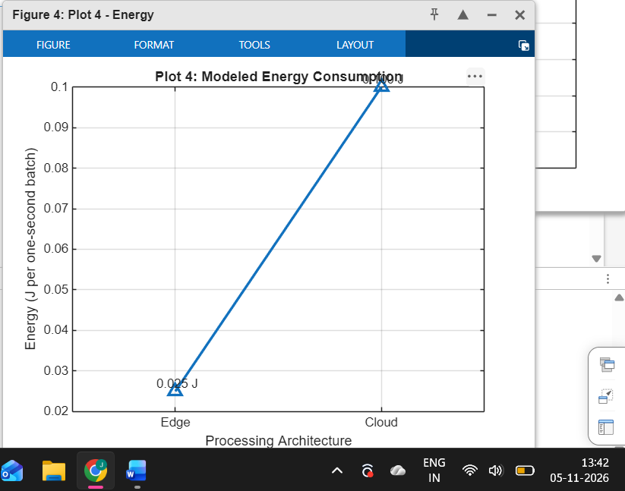

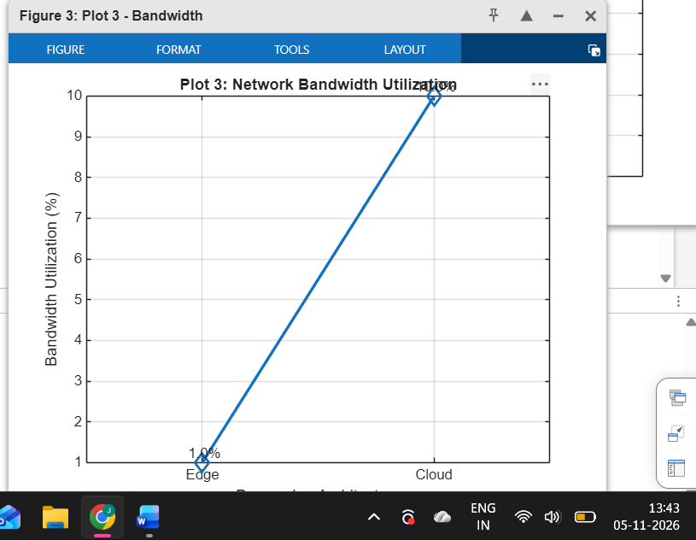

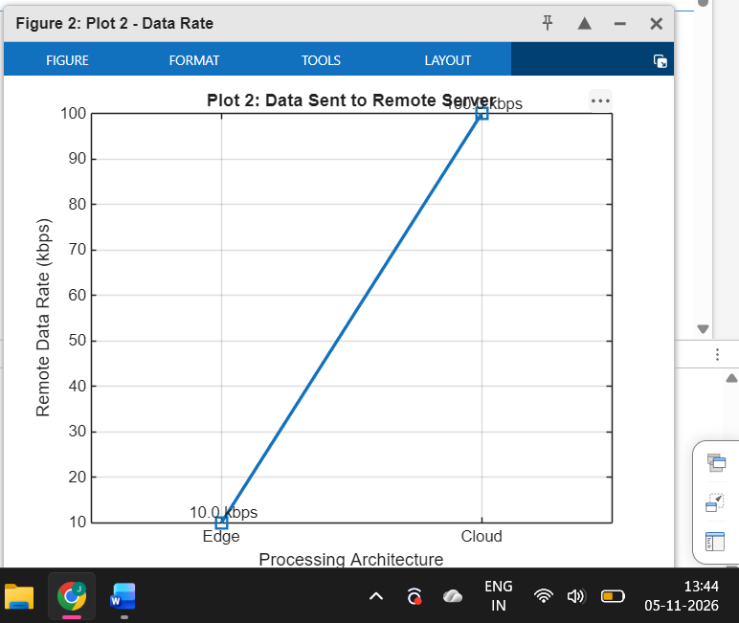

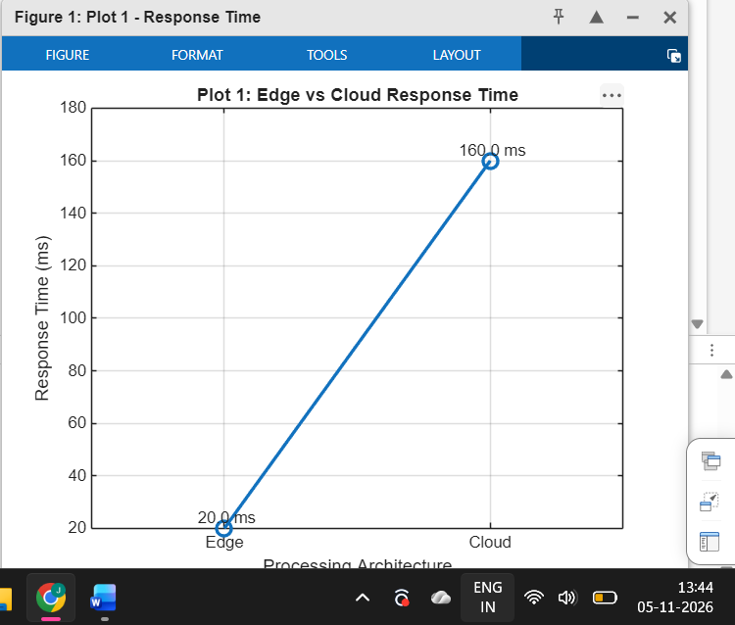

Result
The edge and cloud processing models were successfully simulated using MATLAB. Edge processing reduced remote data transmission and response time under the selected assumptions. Cloud processing provided centralized processing but required more network communication.

